Delinquent Ad Valorem Tax Collection Performance Report

Prepared for:

City of Dallas

2323 Bryan Street, Suite 1600
Dallas, Texas 75201
(214) 880-0089
(800) 441-0960

April 2006
LINEBARGER GOGGAN BLAIR & SAMPSON, LLP

ATTORNEYS AT LAW

UNIVISION CENTER
SUITE 1600
2323 BRYAN STREET
DALLAS, TEXAS 75201
______________________

(214) 880-0089
(800) 441-0960
FAX (214) 754-7167

April 14, 2006

Mary Suhm
City Manager
City of Dallas
1500 Marilla, 4th Floor
Dallas, Texas 75201

Re: Performance Report: Delinquent Ad Valorem Tax; Land Bank;
and Land-Based Receivables Collections

Dear Ms Suhm:

Linebarger Goggan Blair & Sampson, LLP (LGB&S) is pleased to present this performance report regarding the collection of delinquent ad valorem taxes and other land based receivables for the City of Dallas. Our goal is to maximize revenue for our clients – revenue that is sorely needed for vital governmental services. We have represented the City since 1983 and have collected over $264 million in delinquent taxes since being retained. In 2001, the City of Dallas transferred its tax collection operations to Dallas County. Dallas County’s contract for delinquent collections with LGB&S includes representation of the City of Dallas and Dallas ISD.

After consolidation, the City initiated a separate contract with LGB&S for Land-Based Receivable (LBR) collections. This program includes the collection of miscellaneous delinquent liens involving weed, paving, home loan and secured closure accounts. Although 96% of all miscellaneous lien accounts owe delinquent property taxes, we have developed a stand alone collection mailing program for delinquent lien accounts as well as a coordinated litigation program for accounts that owe delinquent taxes and liens. We have collected $4,684,990 in miscellaneous liens as part of our LBR collection program.

In 2004, the City of Dallas entered into an Interlocal Agreement with Dallas County to acquire Land Bank properties through tax foreclosure. The Interlocal Agreement was amended in June 2005 and extended through September 2007, with the 3-year goal of pursuing 1,106 properties, eventually acquiring 885 properties. LGB&S re-tooled its affordable housing unit to file suit on these vacant and distressed properties specifically identified by the City for the revitalization of targeted neighborhoods. To date, we have successfully litigated 119 cases and set 87 properties for Sheriff’s Sale. As allowed by law, the City has conducted a private sale and acquired 47 properties, which are currently in the City’s inventory. Our program is essentially a pro bono effort, since all properties are expected to be struck off to the City’s Land Bank, and the recovery of attorney fees is not anticipated.

This report describes in detail the collection activities we have performed on behalf of the City and the results we have achieved. As always, it is our pleasure to serve the City of Dallas as your delinquent tax collection law firm. Should you require any further information, or simply have a question, please feel free to call me anytime.

Sincerely,

DeMetris A. Sampson
Partner

cc: Honorable Mayor Laura Miller and Members of the Dallas City Council
Tom Perkins, City Attorney, City of Dallas
Nancy R. Primeaux, LGB&S Regional Manager
Performance Report

to the City of Dallas
April 2006

Law Firm Background

LGB&S is the largest and most successful delinquent ad valorem tax collection law firm in Texas. For the past thirty years our law firm has focused on the collection of various types of government debt, and has expanded to represent major cities throughout the nation. Today we collect delinquent taxes for over 1,800 clients, including 494 cities, and 9 of the 10 largest taxing entities in the State of Texas. The exception is Travis County that has not privatized its delinquent tax collection program.

LGB&S employs 1,420 individuals who are dedicated to our collection efforts. We maintain 38 offices in Arizona, California, Colorado, Florida, Illinois, Ohio, Pennsylvania, Tennessee, Texas and Virginia, from which we collect delinquent tax, miscellaneous debt such as weed, paving and demolition liens, highway tolls, hospital and emergency services debts, unemployment benefits, child support and retirement overpayments, state property and income taxes, court and administrative fees, and other government receivables. We are the only law firm, and one of only five vendors, to be awarded a contract to collect miscellaneous federal debts for the U.S. Department of Treasury.

LGB&S is dedicated to optimizing collection efficiency and effectiveness while upholding the highest professional standards. Our collection program is very “hands on” and utilizes multi-faceted collection techniques. We merge advanced collection technologies with the talents of qualified collections personnel. Our law firm practice focuses on the collection of government receivables, which allows us to concentrate our efforts and expertise and maintain our focus on our clients’ needs. We offer customized collection programs for our clients and are the industry leader in computer systems and software support for government collections. Annually, we file over 45,000 lawsuits, mail 6.6 million demand letters and make millions of collections calls to maximize the delinquent revenues for our clients.
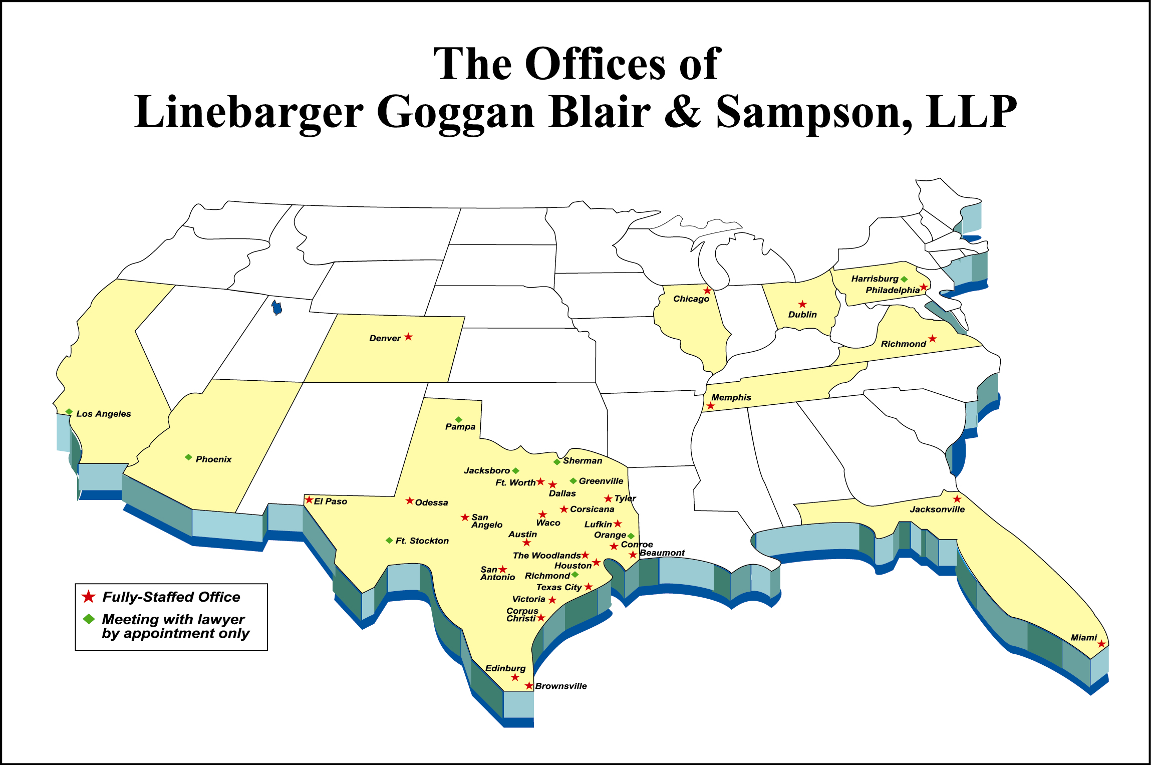
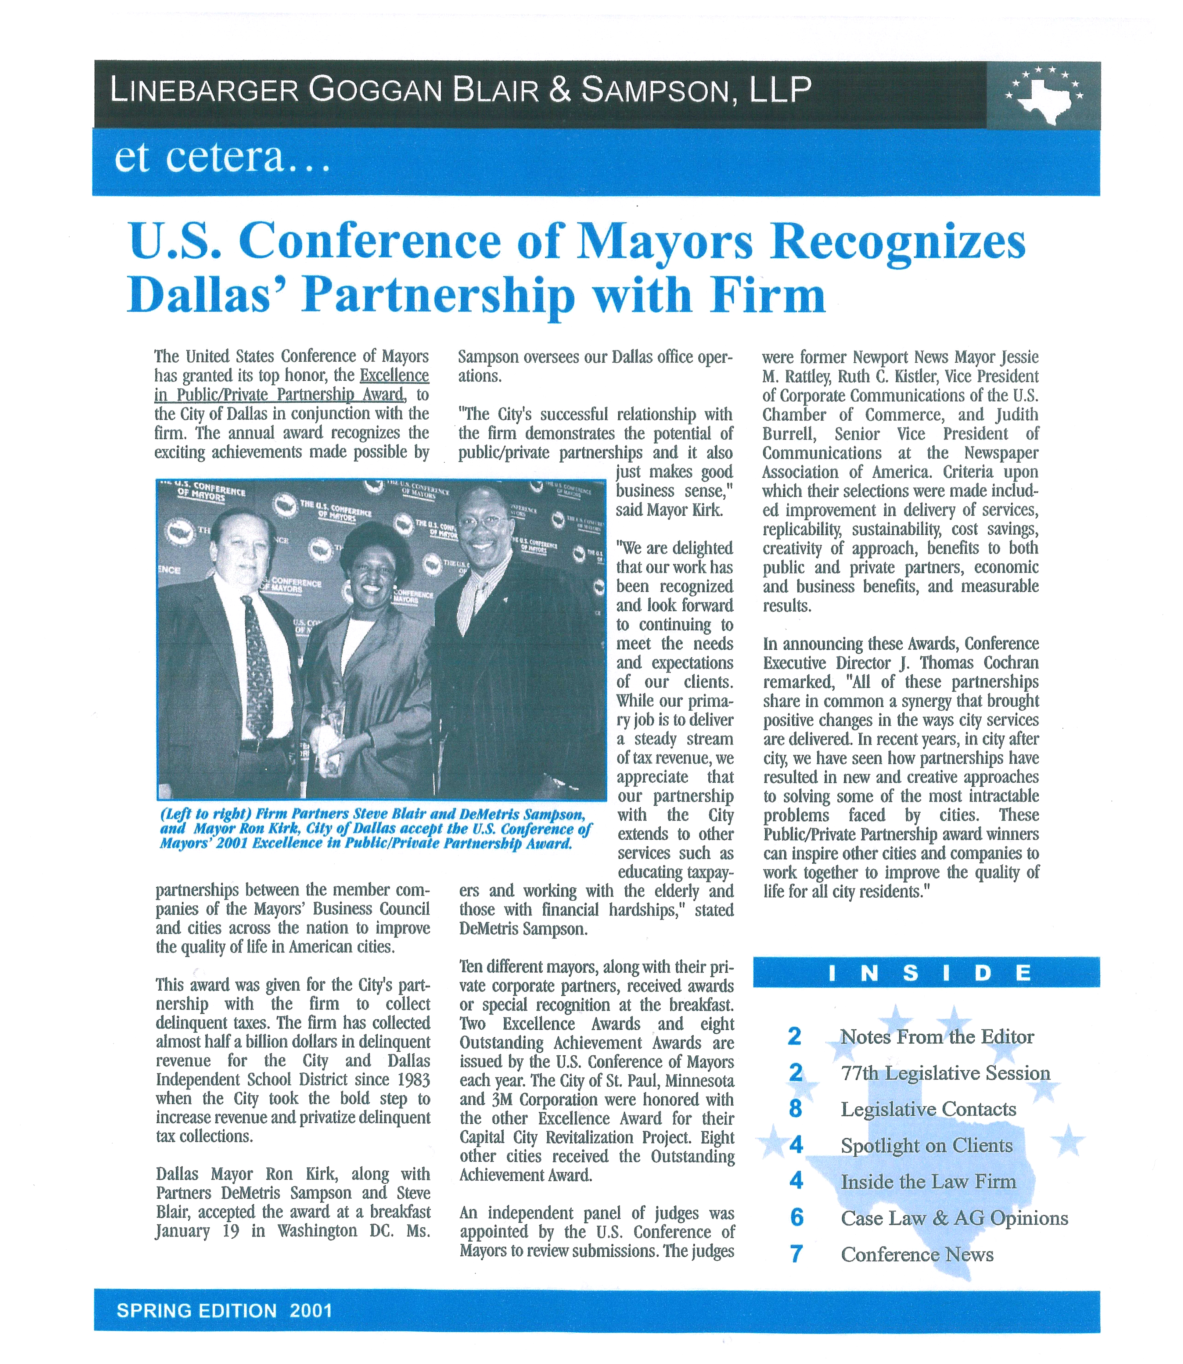
We are proud to have twice been nationally recognized for our municipal collection services. We are especially proud that our first U.S. Conference of Mayors’ Award was bestowed upon the City of Dallas and LGB&S for the delinquent tax collection program we established on your behalf.
          - Winner of the U. S. Conference of Mayors’ 2001 Award of Excellence in Public/Private Partnerships with the City of Dallas – to date over $792 million collected in delinquent tax revenue for City of Dallas and Dallas ISD ($264 million for City).
          - Winner of the U. S. Conference of Mayors’ 2004 Award for Outstanding Achievement in Partnership with the City of Chicago for collecting over $24 million in delinquent fines and fees receivables in less than two years and more than $48 million to date.

Our law firm was also recognized by the Texas Lawyer in 2004 as the “Top Law Firm in Texas” employer of minorities and women. The composition of our entire law firm, with 1,420 employees, is 64% female and 53% minority. Our Dallas Office staff is 79% female and 72% minority. The Dallas Attorney & Management team is 75% female and 54% ethnic minority. Our Dallas Office expended more than $5.3 million ($4.19 million with staff and $1.14 million with subcontractors and vendors) with minorities and women in 2004-2005.

In addition to providing career opportunities through permanent employment, we have also provided a Minority Law Clerkship Program in North Texas each summer since 1987. We strive to utilize local minority and female-owned businesses whenever possible. This includes such services as office supplies, computer equipment, furniture and maintenance agreements. West & Gooden P.C. has provided legal sub-contracting support since 1989. Since 1992, Texas Judgment Recovery Company (TJRC), a Hispanic-owned company, has provided service of civil process as well as title work for the law firm. A woman-owned company, North Texas Research Group, has also provided title work on an on-going basis since 2001 in support of the law firm’s litigation efforts.

LGB&S Dallas Office

LGB&S has maintained an office in downtown Dallas since 1983 in Univision Center and currently employs 113 attorneys and tax professionals who provide collection support to our clients. LGB&S represents 48 taxing entities in Dallas County, including the City of Dallas. Our collections and litigation teams are supported by a staff of 110 IT professionals in San Antonio, Texas.

LGB&S offers a completely unified delinquent tax collection program that coordinates lawsuits, research, bankruptcy representation, foreclosures, site visits, mailings and collection calls. Our consolidated collection program is more efficient and ultimately more effective for all our Dallas County clients. More importantly, it is also more convenient and less confusing for our Dallas citizens.


DeMetris Sampson is the Managing Partner of the Dallas Office. Management Committee Member DeMetris Sampson is responsible for general oversight of all matters in the Dallas office, and formulates policy regarding legal (tax and litigation), legislative, client and affirmative action matters. She currently interfaces with City staff and officials on tax issues and tax related interlocal agreements. Ms. Sampson is immediate past Chair of the firm’s Management Committee and currently chairs the firm’s Legislative Committee. She is active in a variety of business, legal, community, civic and political endeavors. She is a 19-year veteran of the law firm.
DeMetris Sampson, Managing Partner &
Nancy Primeaux, Regional Manager

Nancy Primeaux serves as the law firm’s Regional Manager and has overseen the operations of LGB&S in North Texas since 1986. She manages the staff of collectors, researchers and litigation professionals that has earned an award-winning reputation for their collection services to our clients. She is responsible for work plan development, client relations and reporting. Prior to joining LGB&S, Ms. Primeaux served as the Tax Assessor-Collector for the City of Dallas and Dallas ISD.
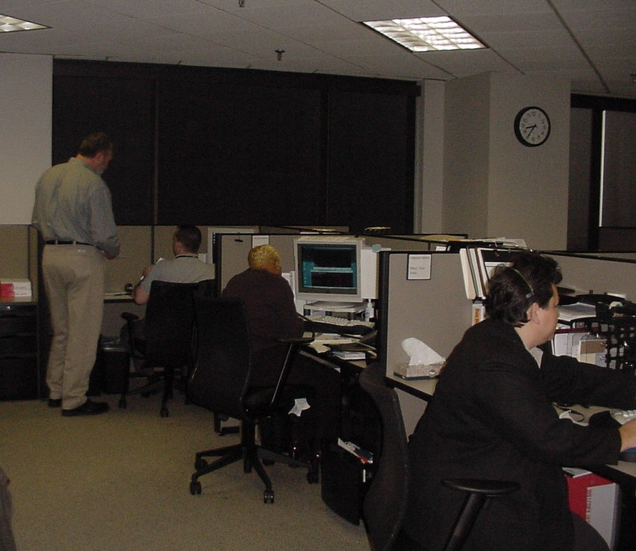
We maintain a toll-free telephone number in order that taxpayers may contact us at no expense. Over 20 of our staff are bilingual and available to assist Spanish-speaking taxpayers.

We employ a 21-person phone bank of professional collectors and researchers that make personal contact with delinquent taxpayers to collect delinquent taxes according to our clients’ specific collection program. All our mailings are supplemented by telephone calls to delinquent taxpayers in order to encourage prompt payment or resolution of their delinquent accounts.
Dallas Office Collections Department

A unit of field collectors conducts personal site visits to businesses and posts “Intent to Seize” notices as part of our pro-active business personal property collection program. Businesses often move or relocate without property taxes being paid. As soon as the delinquent tax roll is turned over to our law firm, we begin targeting, placing personal telephone calls, and performing site visits to determine the company’s assets, ability and/or willingness to pay, and posting notices of our “Intent to Seize”. In 2004-05, we conducted 2,197 site visits and executed 544 bank warrant and tax seizures. In December 2005, the City adopted, at our firm’s recommendation, a legislative change allowing the turn-over of personal property 90 days earlier. We now get these accounts in April instead of July.


Our Litigation Department is comprised of 7 attorneys that are supported by 26 legal assistants who are responsible for preparing and disposing of all tax litigation handled by our Dallas office. Our Post Judgment Department of 8 paralegals and legal assistants reviews all judgments and coordinates all properties set for Sheriff’s Sale and foreclosure.
Dallas Office Litigation Department

In addition, a 4-person unit of litigation collectors is dedicated to making collection calls to property owners and lienholders after a lawsuit has been filed. Their job is to locate and contact taxpayers that have been sued and to collect the money quickly over the phone, rather than more slowly through the court system.

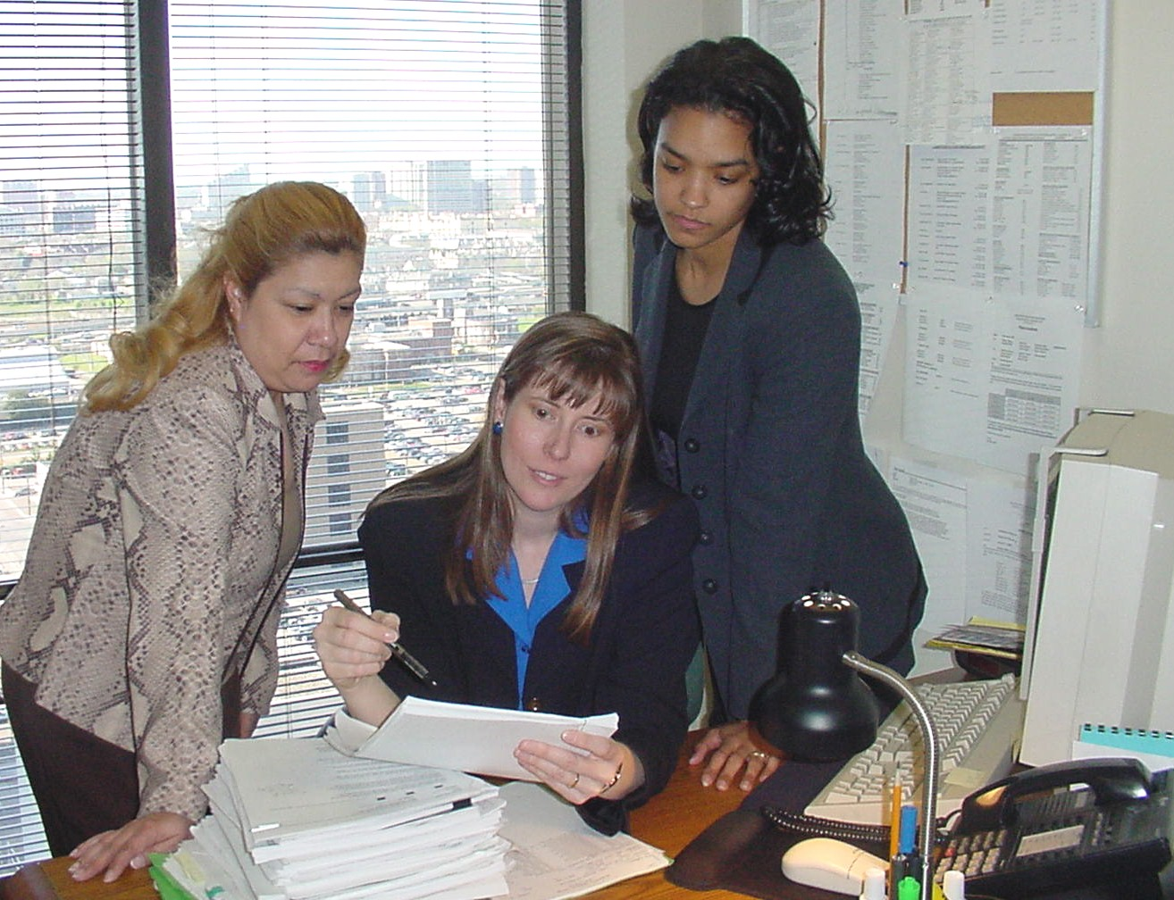
In 1997, our firm created a Unit to pursue properties identified by the City in its affordable housing and code enforcement initiatives. In response to the City’s Land Bank Program, in 2004, we re-tooled this Unit to become our Land Bank Unit comprised of 10 employees consisting of an attorney, paralegals, researchers and an abstractor.
Partner Beth Weller discusses a claim with Bankruptcy Paralegals

Our Bankruptcy Department is staffed by 4 attorneys and 15 legal assistants. Partner, Elizabeth Weller oversees the bankruptcy team. Our bankruptcy team offers complete legal services and representation to our clients in all bankruptcy courts within the continental United States. Our bankruptcy unit is part of our Statewide Bankruptcy Division (10 attorneys and 38 legal staff) that has experience in over 50,000 active and resolved bankruptcy cases representing in excess of $250 million in taxes. Additionally, this Division has been instrumental in affecting invaluable changes in Federal Bankruptcy Code to protect the interests of not only our clients, but all government entities that depend on collections for revenue.

Our litigation and bankruptcy teams contribute to the City’s overall goals in many ways. Most recently, through a combination of efforts in litigation and bankruptcy, the City of Dallas acquired the Dallas Grand Hotel’s parking garage in exchange for the tax delinquency and hotel occupancy taxes owed to the City. This acquisition is a part of the City’s downtown redevelopment efforts.

Delinquent Ad Valorem Tax Collection Performance

LGB&S’ collection history is proven and predictable, a fact on which the City of Dallas has been able to rely for the past 23 years. We have historically maintained high levels of collections in both good and bad economic times.

We have collected $264,113,983 in delinquent tax, penalty, interest and attorney fees for the City of Dallas since July 1983. Prior to the City and Dallas ISD contracting with Dallas County for current tax collection services in 2001, LGB&S historically reported combined City of Dallas and Dallas ISD tax collection totals which, as shown below, total $792,341,949 since the inception of our contract in 1983. On an annual basis, the split was approximately one-third City revenue and two-thirds School District revenue.
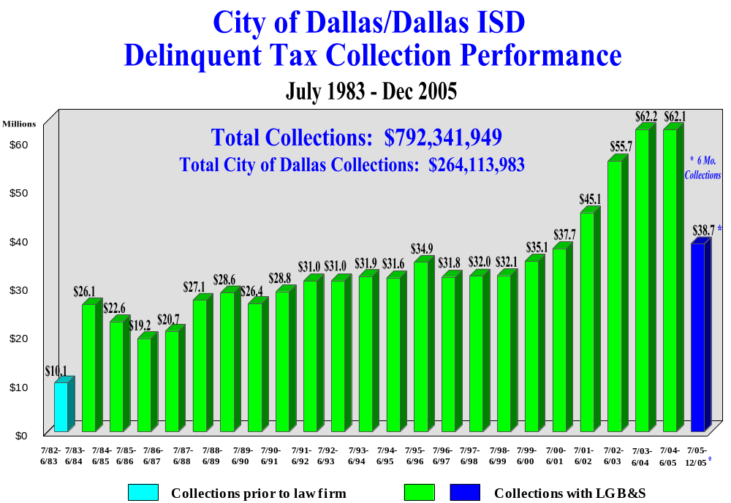

Since consolidating with Dallas County, we now can also report our delinquent collections for the City separately. As shown below, we have collected $264,113,983 since July 2001. In the most recent 6-month period, 7/01/2005 – 12/31/2005, we have collected $13,166,768, which is $957,731, or 7.8% more than the same 6-month period in 2004.

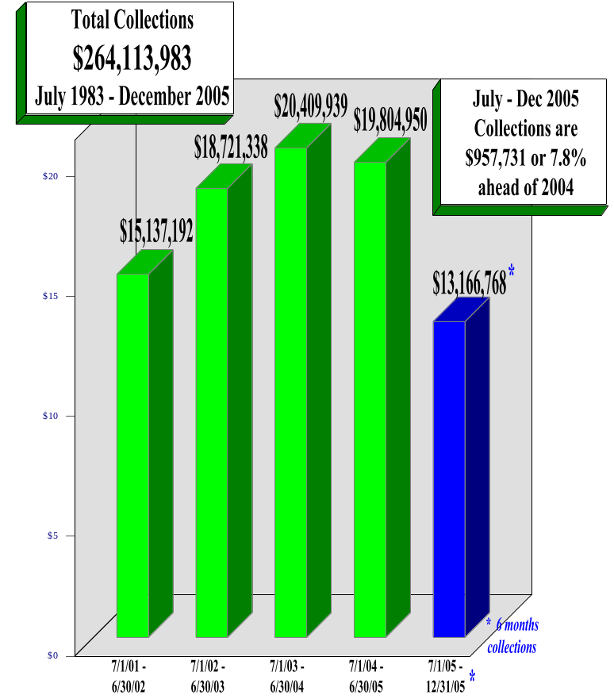

A recap of our collection activities is shown in the “Delinquent Tax Collection Program Highlights for City of Dallas” on page 10. Our collection program is multifaceted and is comprised of a full array of on-going collection activities that are supplemented by targeted, specialized collection efforts. This past year, we have conducted 6 separate mass mailings (consisting of 73,962 letters), performed 2,197 personal site visits to businesses and executed 544 seizures. Each year our call center of collectors handles over 45,000 telephone calls.

LGB&S has filed over 43,000 lawsuits on behalf of the City since 1983 with 1,795 being filed this past year. Our law firm has disposed of 89% of all litigation we have filed, with 2,766 lawsuits being disposed last year. Litigation is a large part of our collection program. The annual Court capacity for handling the filing of new cases is approximately 2,300 per year (for all jurisdictions and all property types, including properties identified by the Land Bank Demonstration Program).

It is very important that the taxpaying public not be able to discern a selective pattern for the filing of litigation. Therefore, cases must be chosen across the economic and geographic spectrum. However, to optimize the use of our resources as well as the resources of the court, we give greater weight to higher dollar amounts as well as accounts with multiple years of delinquency when prioritizing our lawsuit filing efforts. LGB&S carefully selects accounts for litigation, always weighing the Court’s capacity limitations with the City’s need to maximize revenue, balanced by the City’s goal to acquire distressed properties for Land Bank housing initiatives.

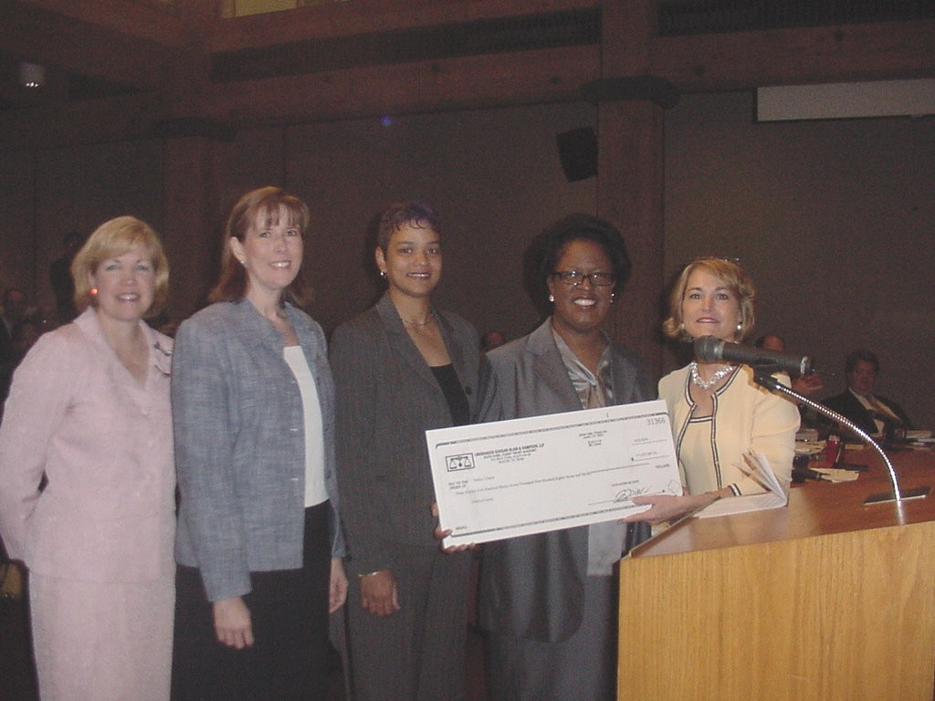
LGB&S protects the City’s interest in all bankruptcies that involve delinquent taxes. The total amount of delinquent tax involved in bankruptcy due to the City has doubled in the past 4 years. Last year, LGB&S filed 4,957 proofs of claim totaling $16.2 million for the City. We are currently handling 3,910 bankruptcy accounts owing $23.7 million to the City.

One example of LGB&S’ successful bankruptcy representation is our collection of over $11 million for our statewide clients in the MCI/WorldCom bankruptcy. As shown here, LGB&S is presenting Dallas County Judge Margaret Keliher a check for $3.6 million, which is the City of Dallas, Dallas County and Dallas ISD portion of the total MCI recovery.
LGB&S Presenting Check for MCI/WorldCom Bankruptcy to Dallas County

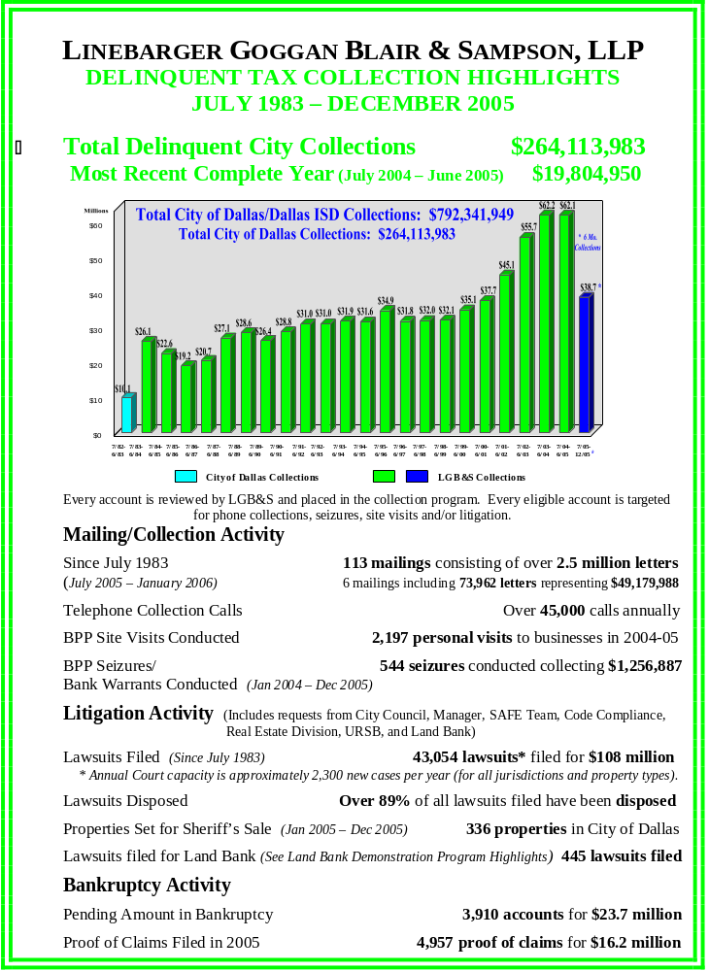

Tax Roll Analysis

We analyze the City of Dallas’s delinquent tax roll on a regular basis in order to customize our collection program to maximize collections on your behalf. Delinquent tax collection performance is greatly determined by both the economy and the make up (age, property type and size) of the delinquent tax roll to be collected. Each July we provide a complete tax roll analysis to the City for its use while preparing the next year’s budget.
As of March 2006, 57,867 accounts, owing $34,747,026 in base tax ($71,069,956 in base tax, penalty and interest), remain on the delinquent tax roll. An analysis of the delinquent tax roll; by property type and size of delinquency, is included on page 12 entitled City of Dallas Total Delinquent Tax Roll – Turned Over to LGB&S. The delinquent tax roll is comprised of both real property and personal property. Real property accounts comprise the majority (52.6% of all base tax dollars due) of the City’s delinquent tax roll, while business personal property accounts comprise 47.7%. By their nature, business accounts are more difficult to collect and generally require an aggressive business personal property collection program.

The tax roll analysis also profiles the size of the delinquent accounts, which helps us “work smart” and determine the appropriate collection strategy. As shown, 33,801, or 59% or the accounts owe less than $200. In turn, 6,857 accounts owe in excess of $1,000, and represent 72% of the total dollar amount of delinquency. We have further analyzed the Collectibility Status of Real Property Accounts. As shown, 18,846 accounts that represent 80.8% of the total dollars due are already in litigation, bankruptcy or being pursued in some other collection status. Of the remaining 9,750 accounts, 8,874 owe less than $1,000.

We have also included a chart detailing the Status of Delinquent Tax Roll on page 13 that provides a more in-depth analysis of the outstanding delinquency and our collection efforts. In total, 87% of all property which is delinquent to the City as of March 2006 is in litigation, bankruptcy or is legally delayed from collection activity. We remain committed to maximizing the City’s collections and are aggressively pursuing the remaining 13% of the City’s delinquent tax roll through collection efforts which include litigation, seizure and personal site visits.

CITY OF DALLAS TOTAL DELINQUENT TAX ROLL – TURNED OVER TO LGB&S
(As of March 2006)
Total Base Tax, Penalty, Interest & Attorney Fees (2004 and Prior) | 57,867 accounts for $71.1 million
Total Base Tax (All Years) | $34.7 million
2004 Base Tax | $7.6 million

BREAKDOWN OF TOTAL LGB&S DELINQUENT TAX ROLL
Type of Account | Number of Accounts | Base Tax | Base Tax + P&I | % of Base Tax Dollars
Real Property | 28,596 | $18,278,071 | $38,282,344 | 52.6%
Personal Property * | 29,271 | $16,468,955 | $32,787,612 | 47.4% *
TOTAL | 57,867 | $34,747,026 | $71,069,956 | 100%
* City approved recent change in law (Tax Code Sec. 33.11) allowing early turnover of delinquent personal property accounts for collections. 2005 delinquency will attach collection penalty and be turned over to LGB&S April 4, 2006 (3 months earlier than in 2005).
Dollar Amount | Number of Accounts | Base Tax + P&I | % of Number of Accounts | % of Base Tax + P&I Dollars
$0-200 | 33,801 | $ 3,889,528 | 58% | 5%
$200-1000 | 17,209 | $15,988,750 | 30% | 23%
$1000-ABOVE | 6,857 | $51,191,678 | 12% | 72%
TOTAL | 57,867 | $71,069,956 | 100% | 100%

COLLECTIBILITY STATUS OF REAL PROPERTY ACCOUNTS
Status of Real Property Accounts | Number of Accounts | Base Tax | Base Tax + P&I | % of Base Tax Dollars
Clean (Eligible) | 9,750 | $ 4,044,615 | $ 7,367,536 | 19.2%
In Litigation/Bankruptcy  /Collection Status | 18,846 | $14,233,455 | $30,914,808 | 80.8%
TOTAL | 28,596 | $18,278,071 | $38,282,344 | 100%
Size of Accounts – Eligible Real Property | Number of Accounts | Base Tax | Base Tax + P&I | Average Size of Accounts  (Base + P&I)
$0-200 | 4,545 | $ 398,341 | $ 669,130 | $ 147
$200-1000 | 4,329 | $1,966,234 | $3,410,469 | $ 788
$1000-ABOVE | 876 | $1,680,040 | $3,287,938 | $3,753
TOTAL | 9,750 | $4,044,615 | $7,367,536 | $ 756

City of Dallas Land Bank & Affordable Housing Initiative

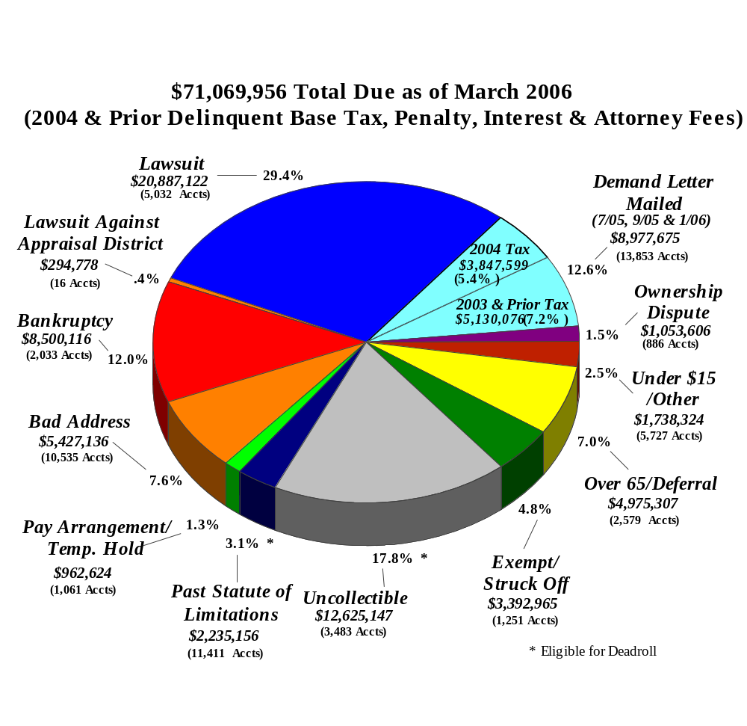
Status of Delinquent Tax Roll

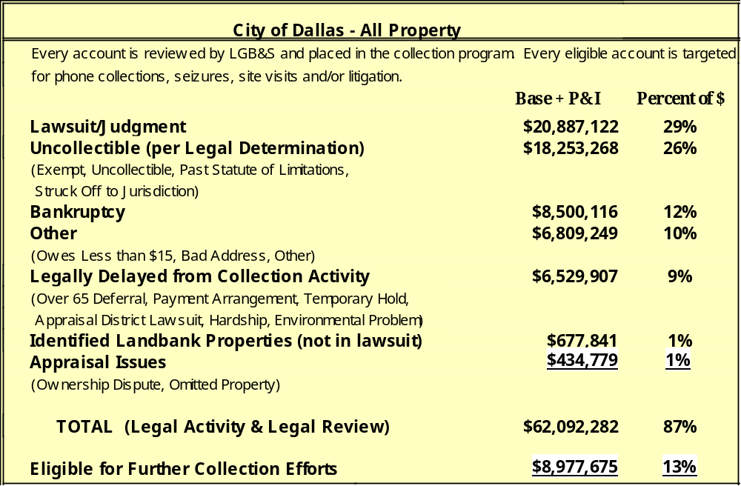

Linebarger Goggan Blair & Sampson, LLP supports the City of Dallas’ Land Bank Demonstration Program and its affordable housing initiatives. Between 1997 and June 2004, the law firm conducted litigation at the City’s request, aimed at enhancing the City’s affordable housing and code enforcement efforts. Properties were referred to LGB&S from the City and non-profit organizations as candidates for affordable housing. During this time:

- Over 2,100 lawsuits were filed, including miscellaneous liens.
- 805 properties (including miscellaneous liens) were posted for Sheriff’s Sale (Since 2000).

In July 2004, the City created a Land Bank Demonstration Program with the goal of acquiring properties for its affordable housing efforts. LGB&S agreed to prosecute delinquent properties pursuant to a June 2004 Interlocal Agreement for the City’s Land Bank initiative, between the City of Dallas and Dallas County. This agreement covers the fiscal years of 2003-04 (106 properties), 2004-05 (375 properties) and 2005-06 (625 properties) with the goal of pursuing 1,106 properties, eventually acquiring 885 properties. The law firm’s litigation and foreclosure efforts supply properties for the City’s Land Bank. Once a property is posted for sale, the City is responsible for conducting a private sale to acquire these properties into its inventory. The Interlocal Agreement called for 625 properties to be pursued in fiscal year 2005-06, but to date only about 70 properties have gone through the approval process at the City Attorney’s office, have had title work performed and been forwarded to our law firm for filing. To date, LGB&S has filed 445 lawsuits and the City has acquired 47 properties.

Our program is essentially a pro bono effort, since all properties are expected to be struck off to the City’s Land Bank, and the recovery of attorney fees is not anticipated. In a delinquent tax lawsuit, abstractors, process servers, court personnel, Sheriff’s office personnel, law firm, etc. are paid if, and only if, the taxes and court costs are paid. By definition, these targeted land bank properties typically have low tax amounts, low values, high lien amounts, do not sell at Sheriff’s sale and are therefore struck off resulting in non-payment of costs and fees. LGB&S has budgeted over $1 million annually for this program, which includes a dedicated attorney and litigation support staff of 9 legal assistants and researchers, plus bankruptcy representation, information technology support and resources, as well as related overhead.

The chart below highlights the activities and results of the City’s Land Bank initiatives to date:

City Goal | Year 1  FY 2003-2004 | Year 2  FY 2004-2005 | Year 3  FY 2005-2006 | Total
Properties Identified by City of Dallas Land Bank (DLB) & Agreed to by LGB&S Pursuant to Interlocal Agreement | 106 * | 375 | 625 | 1106
DLB’s desired Property Acquisition | 85 | 300 | 500 | 885
Activity
Properties Abstracted by Republic Title Company, Approved by City Attorney & Accepted by LGB&S | 101 | 335 | 66 ** | 502
Approved Properties Subsequently  Paid / Bankrupt / Ineligible | 6 | 33 | 11 | 50
Lawsuits Filed (LGB&S) | 95 | 302 | 48 | 445
Judgments Granted (LGB&S) | 70 | 48 | 1 | 119
Orders of Sale Requested (LGB&S) | 67 | 20 | 0 | 87
Acquisition
Properties in City Inventory Results from Private Sale Conducted by City of Dallas | 44 | 3 |  | 47
* Although 106 were agreed upon pursuant to the Interlocal Agreement, an additional 4 properties were included in
FY 2003- 2004 though substitution & referral.
** Any additional pending properties for FY 2005-2006 are to be submitted by the City of Dallas to LGB&S by
March 31, 2006 pursuant to the Interlocal Agreement.

Land-Based Receivables Collection Program

LGB&S began collecting the City’s Land Based Receivables (LBR) accounts in August 1997 as part of our delinquent tax collection contract with the City. Collections included amending LBR liens into tax lawsuits whenever possible, and conducting special mailings to collect the outstanding liens. Land-based liens or miscellaneous code violation liens include weed, paving, demolition, secured closures and home loans.

The vast majority (96%) of all LBR liens are attached to accounts that also owe delinquent taxes. The Highlights page that follows details our collection efforts and stratifies the outstanding delinquency of the land based liens that have been turned over to LGB&S for collections. We have conducted 25 mailings and filed 2,038 lawsuits on accounts that owe both delinquent taxes and liens. Of all the tax litigation we file for the City, 27.5% includes land-based receivable liens and 38% of all properties set for Sheriff’s Sale include liens.
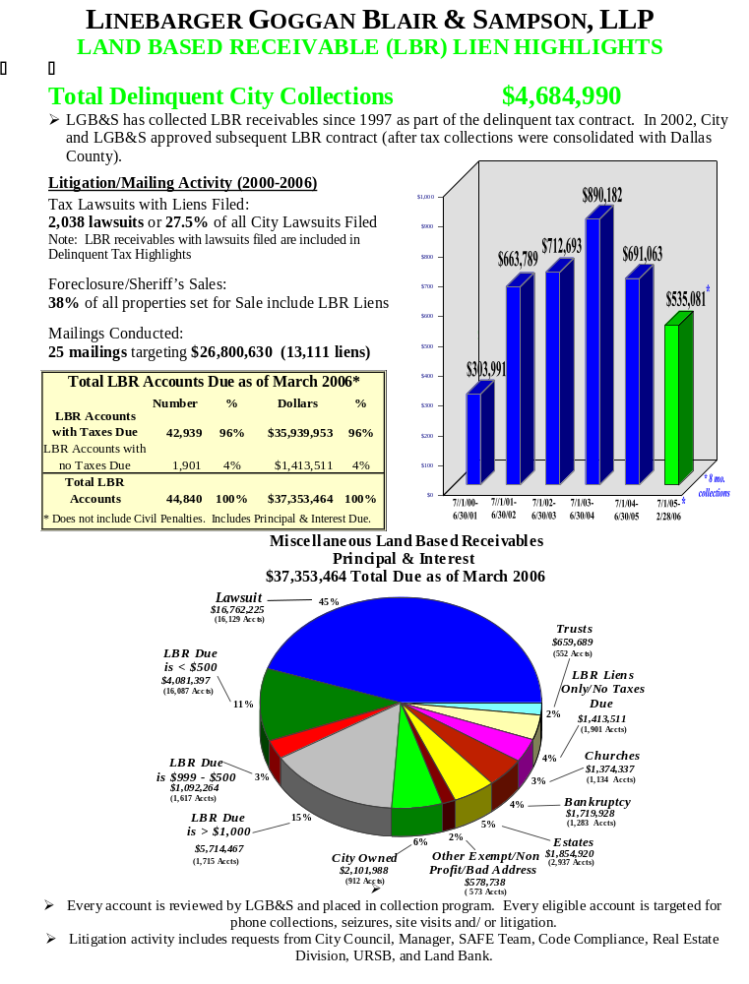

Computer Hardware & Software

For almost 30 years, LGB&S has pioneered the use of technology to reshape the delinquent tax collection industry. As a major high-tech employer, we provide data processing and other computer resources to governmental entities throughout the nation. Our representation of the largest taxing jurisdictions in Texas and the United States has led us to invest more than $32 million to develop the most advanced data processing and communication technologies in the business and has allowed us to meet the changing needs of the tax collection industry.

Our Information Technology center, headed by Rich Pachecano, consists of over 110 information technology specialists that support our network of offices.

Our data processing systems are designed to manage all aspects of our collection program including: (1) tracking delinquent account collections, (2) mailing standard and customized notices including follow up return mail notices, (3) filing and monitoring lawsuits and bankruptcies, and (4) reporting for accountability and statistics. We have our own computer systems (IBM and various servers HP, SUN, Intel and Dell) and proprietary software developed specifically for use in collecting receivables for our clients. Our system currently manages over $1.1 billion worth of receivables for our delinquent tax clients, and tracks over 100,000 related lawsuits and bankruptcy cases throughout the United States.

LGB&S was one of the first delinquent tax collection law firms to recognize and design processes that allowed us to utilize state-of-the-art technology to collect delinquent taxes, perform research and file lawsuits, while at the same time support our clients’ operations. Our Dallas office has on-line connectivity to the Dallas District Clerk’s Office, the Dallas County Tax Office, the City of Dallas land-based lien system and various bankruptcy courts throughout the nation.

More than 100 of our employees each day access the Dallas County tax system and Court records in order to run tax statements, quote tax amounts due and collect court costs. We consider ourselves an extension of both the Tax Office and the clerk’s staffs, and handle hundreds of calls each day that otherwise would be directed to the County. We are the only delinquent tax law firm in Dallas County to electronically file both lawsuits and bankruptcy proofs of claim. All new lawsuits are loaded via FTP and cartridge onto the Tax Office and District Clerk records, while all Bankruptcy Proofs of Claim are filed electronically at the Court.

In addition to these activities, LGB&S has developed a computerized lawsuit case tracking and document production system (CATS) and a bankruptcy tracking system (Banktool) that enable our attorneys and staff to monitor and dispose of litigation and bankruptcy cases quickly and effectively. We regularly utilize the research tools available on the Internet, such as background web sites and on-line government sites in order to obtain the most current ownership and address information.

In 2001, LGB&S became responsible for the conversion and consolidation of the City of Dallas and Dallas ISD’s tax data and system into the Dallas County Tax Office. We played a key role in the “Consolidation Work Team” which included representatives of the City, School District, County Auditor, Tax Office and Commissioners Court. This tax office conversion was successfully implemented in April 2001 and has resulted in huge efficiencies for both the City and County. The costs for LGB&S’ efforts in coordinating this successful conversion were at a minimum $250,000 with more than 2,000 hours of programming involved. This work was provided through utilization of the tax system enhancement hours included in the existing delinquent tax contract and was provided at no additional cost to Dallas County, the City of Dallas or the Dallas Independent School District.

LGB&S Serves our Dallas Community

LGB&S has a long history of good community citizenship. We believe that to represent our clients effectively, we must be involved in the communities in which our partners and employees reside. Community organizations supported by LGB&S include:

- Various area Chambers of Commerce
- Greater Dallas Chamber of Commerce, Dallas Black Chamber of Commerce, Greater Dallas Hispanic Chamber of Commerce, and Greater Dallas Asian American Chamber of Commerce
- North Texas Rescue Relief Fund (Hurricane Katrina)

- Various City Outreach Programs
- North Texas Food Bank
- Dallas Bar Foundation
- Friends of Fair Park
- Community Police Funds
- Volunteer Fire Departments
- Santa Cop Programs
- Friends of the Library Programs
- Muscular Dystrophy
- Welcome House, Inc.
- Brighter Tomorrows
LGB&S Presenting Check to Dallas County to support North Texas Rescue efforts for Hurricane Katrina Relief
- UNT Dallas Campus
- YMCA
- Various Education Foundations
- School Honor Societies
- Support of Vocational Education Programs
- Speaking at area school Career Days
- Numerous other local charitable and community programs

Ancillary Services

Legislative Services

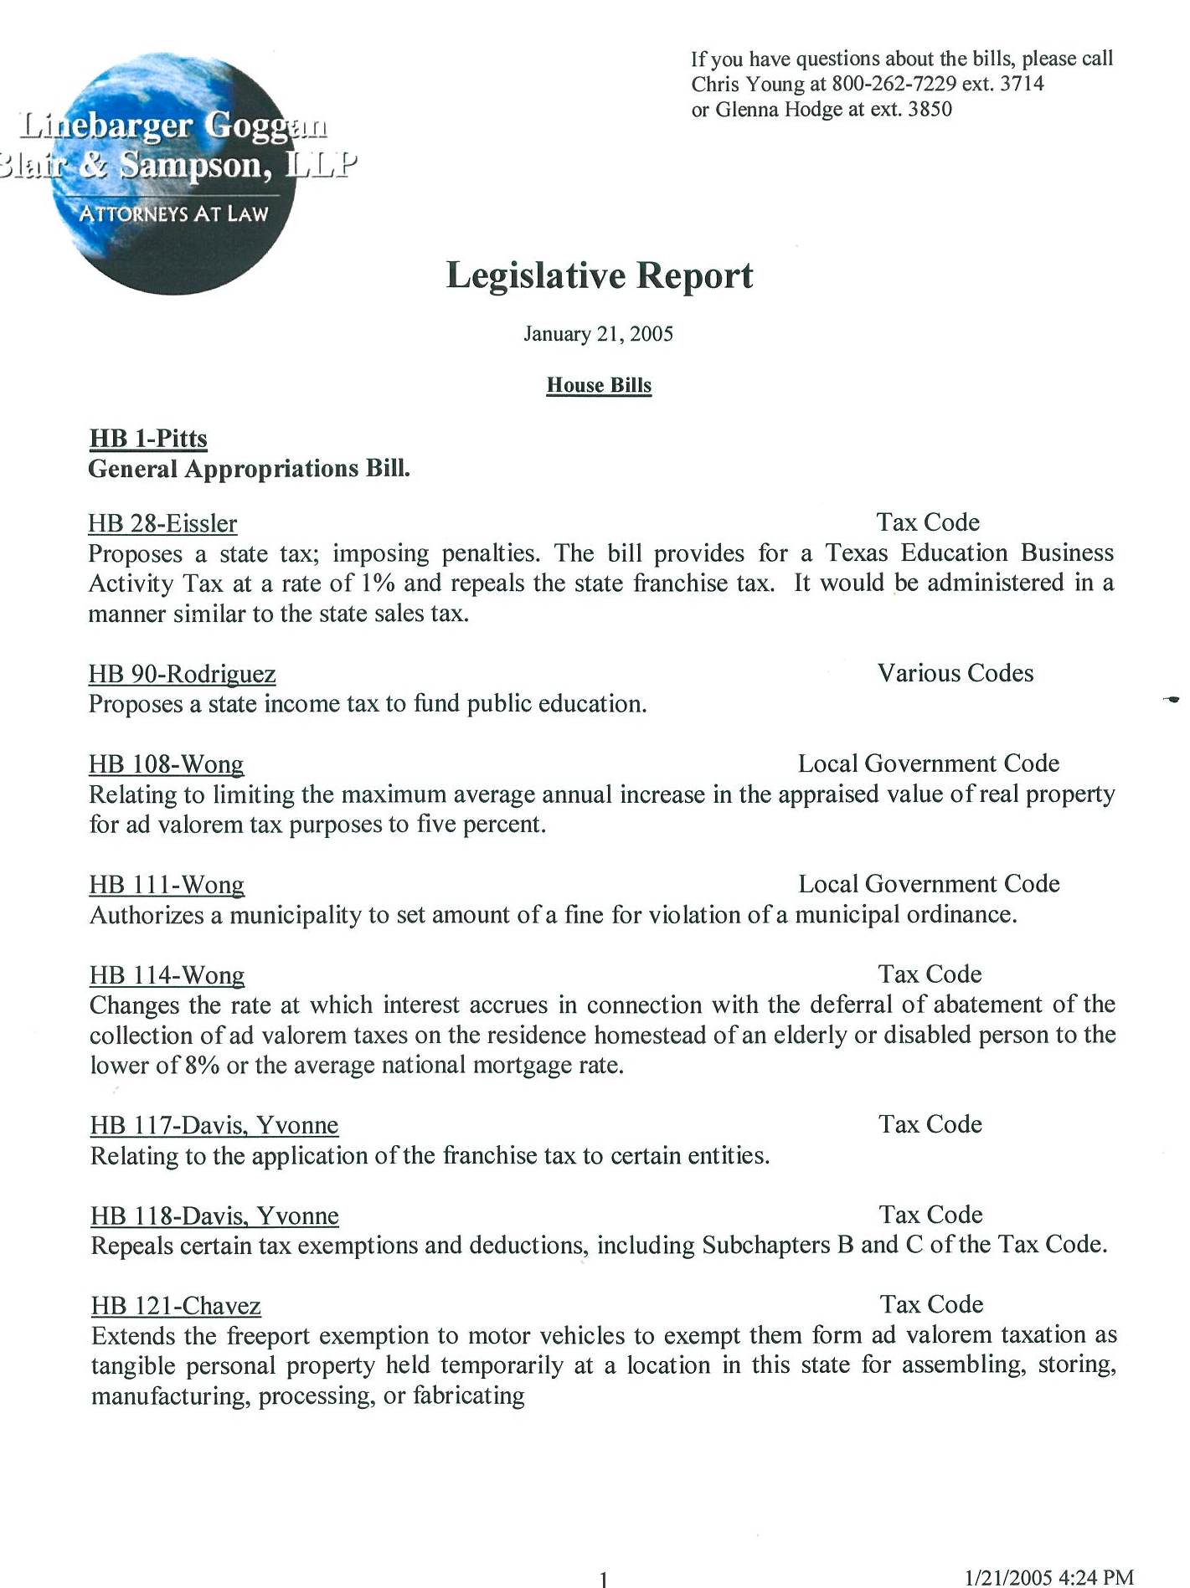Our law maintains an Austin office which offers legislative services that include bill status research, document acquisition, personal contact, and regular legislative reports on legislative matters affecting the Property Tax Code or the welfare of the City. DeMetris Sampson serves as Chairperson of the law firm’s Legislative Committee.

Complex Civil and Civil Appellate Litigation

We represent the City of Dallas at no cost, in all types of lawsuits arising from collection activities, such as counterclaims, injunction suits, eminent domain proceedings, declaratory judgment actions, and all types of complex property tax related litigation.

Taxpayer Assistance / Education

Our staff regularly makes presentations to community groups and organizations interested in learning more about property taxation and taxpayers' rights as requested by the City of Dallas. On-going education is also offered by our firm to our clients as needed and requested. Our attorneys and managers are frequently invited to speak at tax seminars and conferences throughout Texas regarding collection strategies and techniques. At these courses, our clients are able to train their staffs on bankruptcy, legislative changes, collection issues, and obtain the necessary CEUs for professional tax certification.

Toll-Free Networking

Our toll-free telephone network offers access to all of our offices and legal counsel experienced in bankruptcy, appraisal district matters, and complex civil litigation statewide at no cost to the City.

Firm Publications

Our law firm’s quarterly newsletter, et cetera, is distributed to City officials to keep them apprised of changes in legislation, recent judicial decisions and matters of interest concerning the collection of tax and other government receivables.

Media Relations
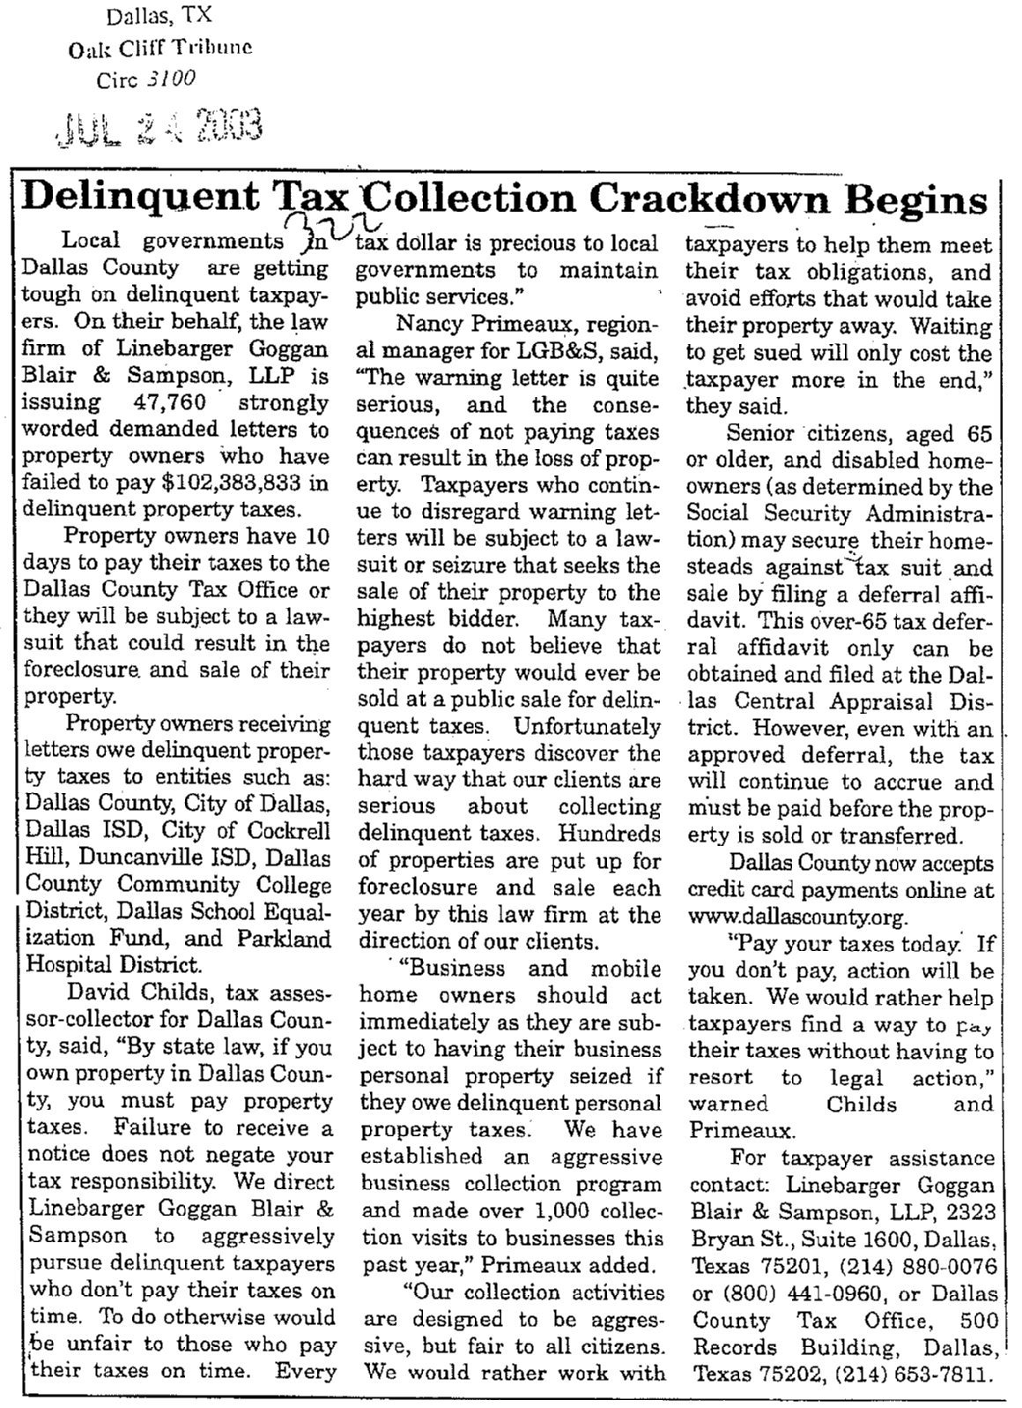
With the approval of the City, experienced public relations professionals periodically integrates media coverage into the City of Dallas collection program to inform property owners of their responsibilities and help deter delinquency. We draft press releases for local television, radio and print media in addition to conducting press conferences for high-profile collection activities. We initiate media coverage on mailing, lawsuit filings, tax seizures and any other significant collection initiative. We have been particularly successful in the Dallas area in getting the media to cover news stories related to our tax collection efforts.

Fees

Compensation for our efforts is paid by the delinquent taxpayers and not the City of Dallas. State law allows a collection penalty of 20% to be “added-on” to the total amount of delinquent tax, penalty and interest. This collection penalty is paid by the delinquent taxpayer and is passed on to the law firm as compensation for our collection efforts if, and only if, we are successful in collecting delinquent taxes for the City.

Our fees are contingency based which means LGB&S is not compensated until and unless the City is paid. LGB&S bears all costs of operations. We also represent the City of Dallas at no cost, in all types of lawsuits arising from collection activities, such as counterclaims, injunction suits, eminent domain proceedings, declaratory judgment actions, and all types of complex property tax-related litigation.

